1. **Launch one ec2 using Amazon Linux 2 image and add script in user data to install Apache.**

Go to EC2 instances and click on launch instance and Give name as you requirement and select Amazon linux from AMI and select Amazon linux 2 AMI(HVM)

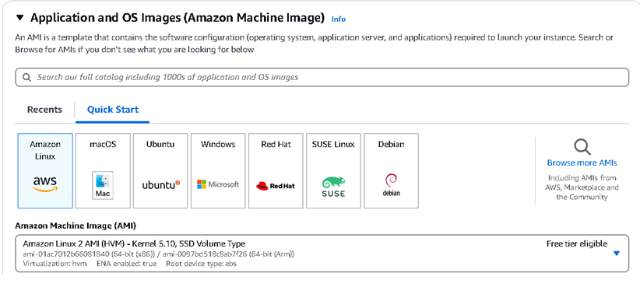

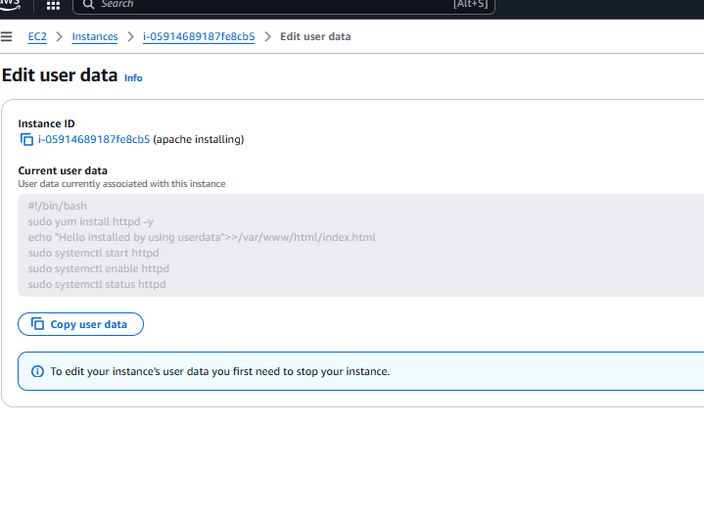

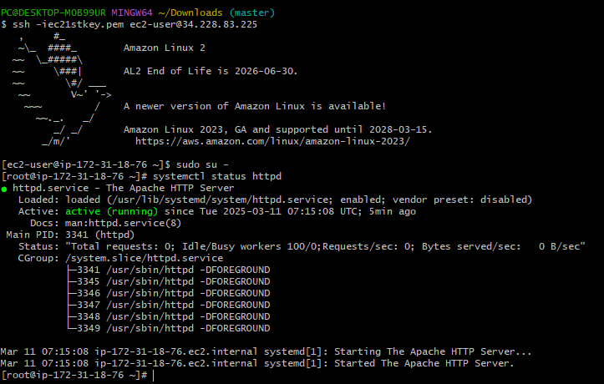

*We can see the httpd is active and running on the browser as well*

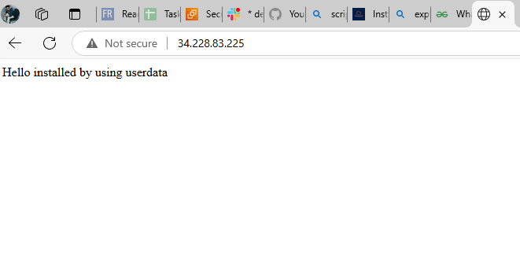

**2).Launch one ec2 using Ubuntu image and add script in user data to install Nginx**

Go to EC2 instances and click on launch instance and Give name as you requirement and select Ubuntu from AMI and select Ubuntu server

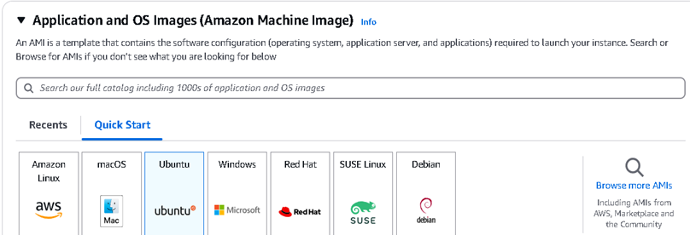

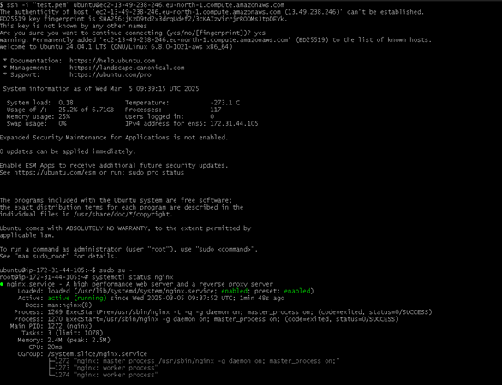

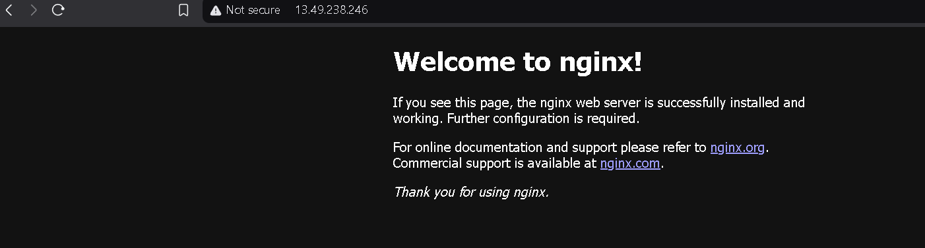

1. **Launch one windows server and install tomcat in windows**. 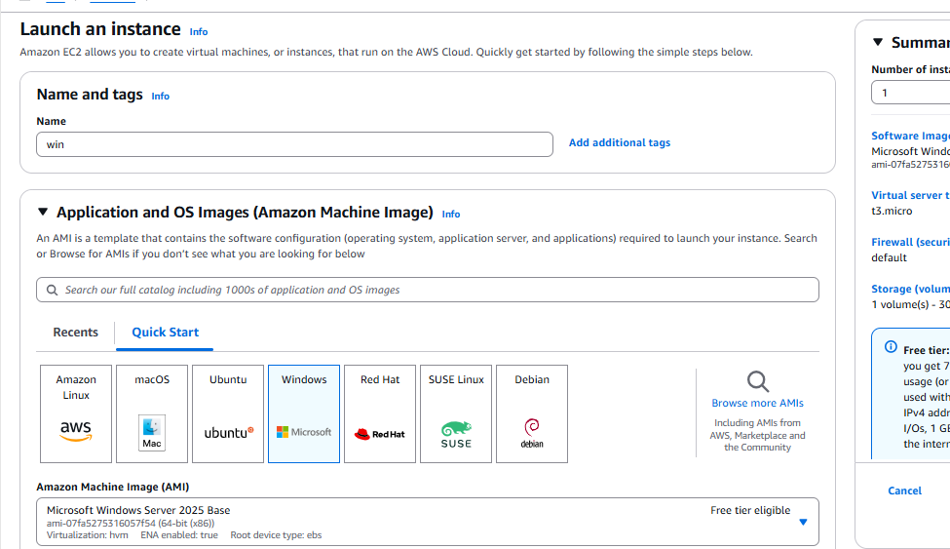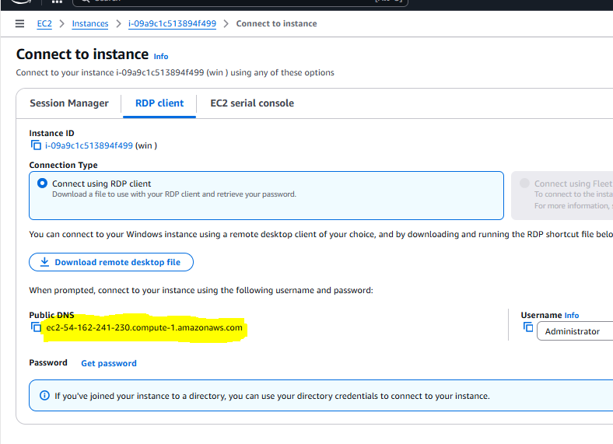

**If we want to connect to windows EC2. We need to download Remote Desktop file and use RDP to connect**

**We need to decrypt the password and enter in RDP to connect the Remote Windows machine**



**Then Install Java in the windows machine.**

**Then go to** [**Https://tomcat.apache.org**](Https://tomcat.apache.org) **and download and install Apache tomcat**

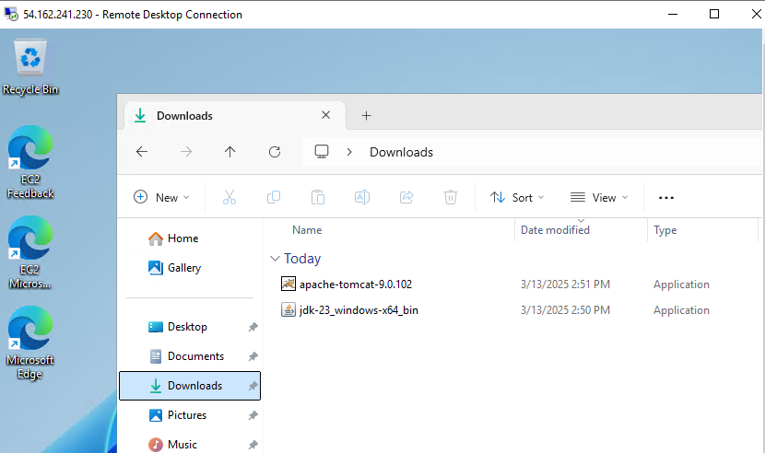

**Now check on the browser by using localhost:8080**

Now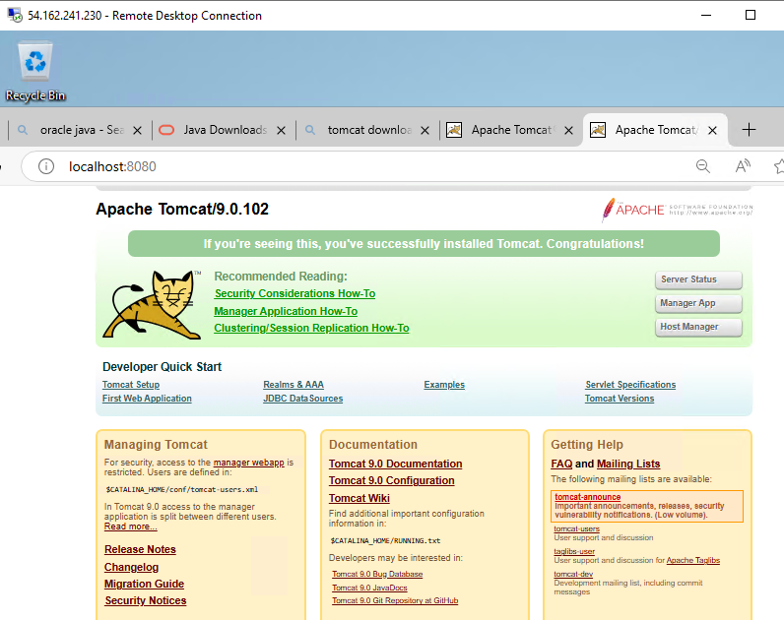

1. Take snapshot of the instance created in Task 1.

**Select the instance and click on storage then click on Volume Id**

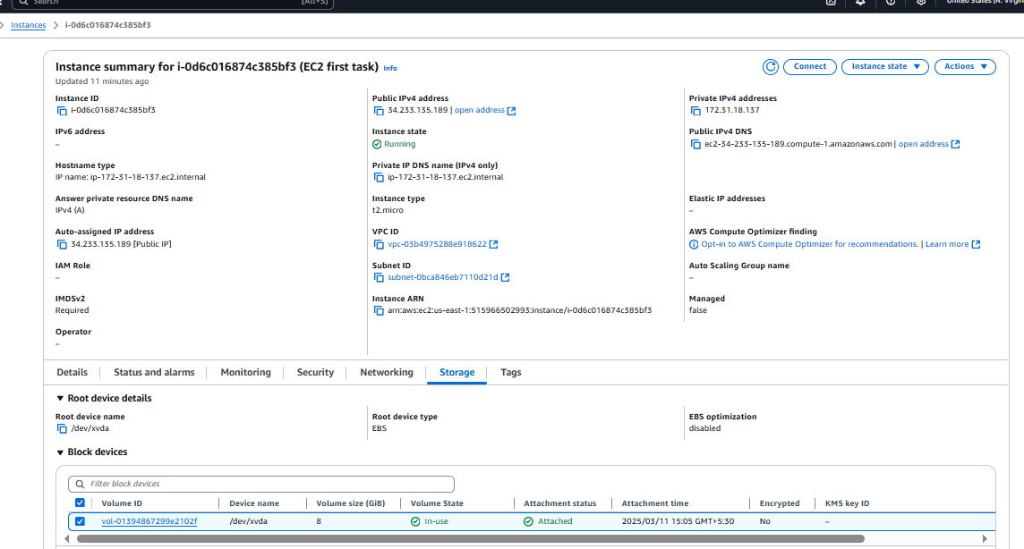 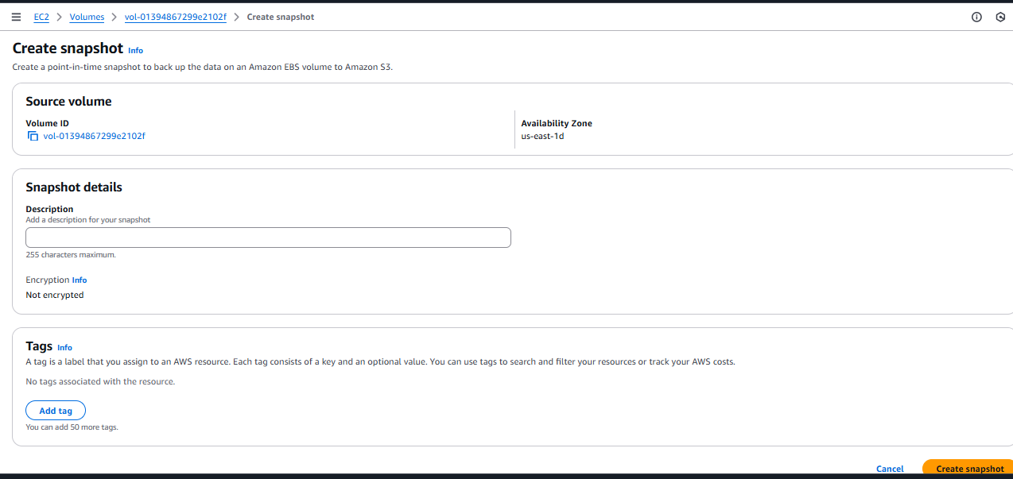 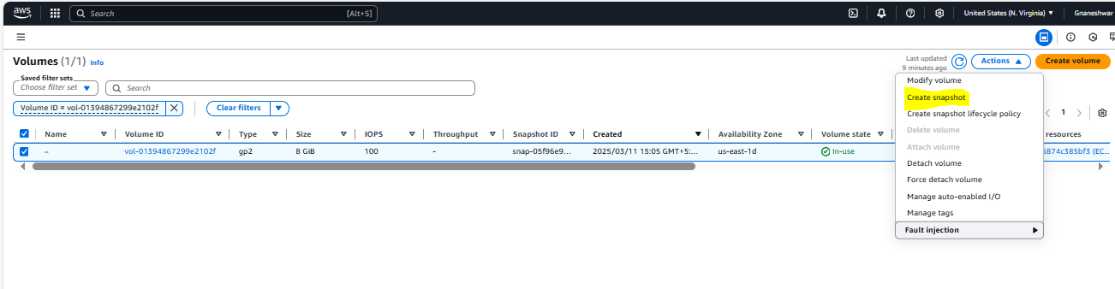

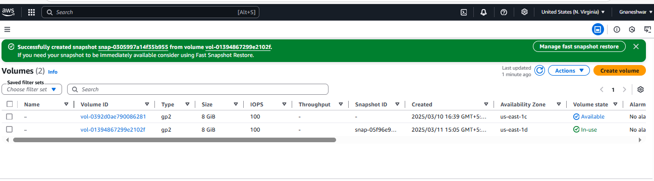

1. Assign password less authentication for ec2 created on Task 2.

**To make ec2 passwordless authentication**

**Goto --🡪 /etc/ssh/sshd_config and edit content using**

**vi** **/etc/ssh/sshd_config ---->change password authentication “No” to “YES” ,so that anyone can access the server**

**And then *restart the sshd***



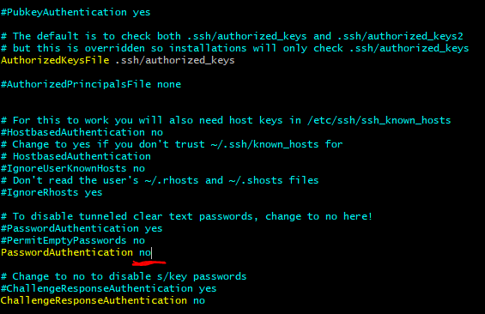

1. Launch any ec2 using spot purchasing option.

**For launching instance an ec2 using spot purchase option we need to select the “*Spot instance*” under Purchasing option**

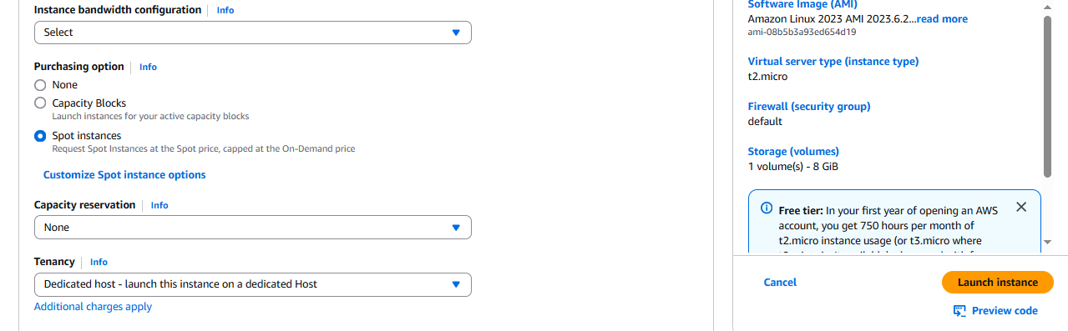

1. Enable Termination policy on ec2 created in Task 2.

**Click on Actions->Instance Settings->Change termination protection**

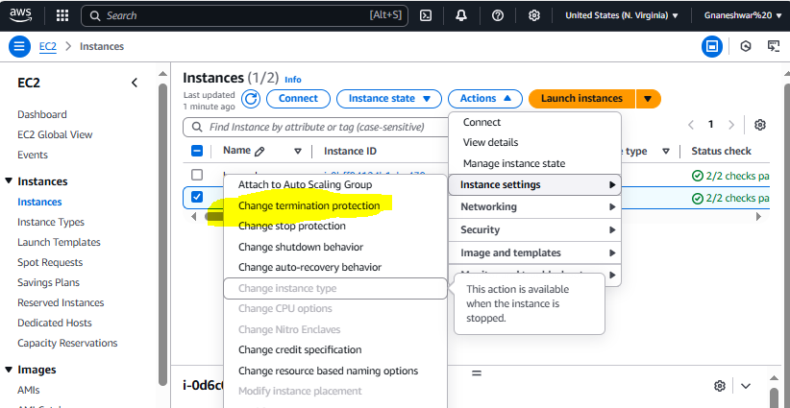

**Choose Enable option and save**

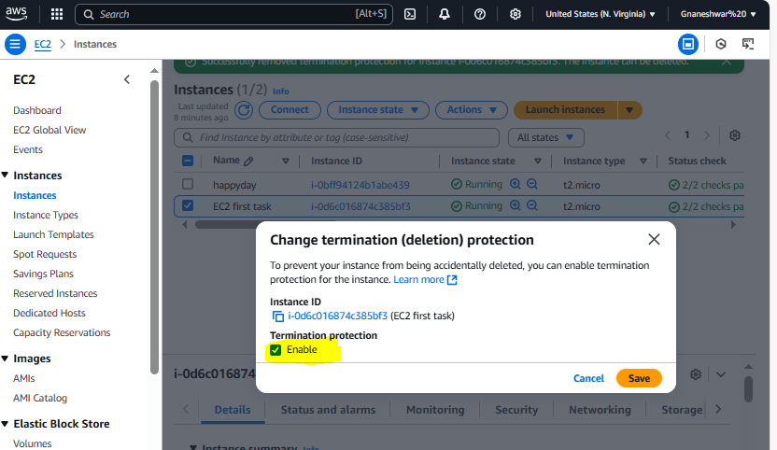

1. Launch one ec2 using Aws CLI.

**You can see the AMI ID at the bottom in the below image the AMI,we will use this ID to create instance AWS CLI**

